How do I connect to the Internet?
Once you've set up your computer, you may want to purchase home Internet access so you can send and receive email, browse the Web, stream videos, and more. You may even want to set up a home wireless network, commonly known as Wi-Fi, so you can connect multiple devices to the Internet at the same time.

Types of Internet service
The type of Internet service you choose will largely depend on which Internet service providers (ISPs) serve your area, along with the types of service they offer. Here are some common types of Internet service.
- Dial-up: This is generally the slowest type of Internet connection, and you should probably avoid it unless it is the only service available in your area. Dial-up Internet uses your phone line, so unless you have multiple phone lines you will not be able to use your landline and the Internet at the same time.
- DSL: DSL service uses a broadband connection, which makes it much faster than dial-up. DSL connects to the Internet via a phone line but does not require you to have a landline at home. And unlike dial-up, you'll be able to use the Internet and your phone line at the same time.
- Cable: Cable service connects to the Internet via cable TV, although you do not necessarily need to have cable TV in order to get it. It uses a broadband connection and can be faster than both dial-up and DSL service; however, it is only available where cable TV is available.
- Satellite: A satellite connection uses broadband but does not require cable or phone lines; it connects to the Internet through satellites orbiting the Earth. As a result, it can be used almost anywhere in the world, but the connection may be affected by weather patterns. Satellite connections are also usually slower than DSL or cable.
- 3G and 4G: 3G and 4G service is most commonly used with mobile phones, and it connects wirelessly through your ISP's network. However, these types of connections aren't always as fast as DSL or cable. They will also limit the amount of data you can use each month, which isn't the case with most broadband plans.

Choosing an Internet service provider
Now that you know about the different types of Internet service, you can do some research to find out what ISPs are available in your area. If you're having trouble getting started, we recommend talking to friends, family members, and neighbors about the ISPs they use. This will usually give you a good idea of the types of Internet service available in your area.
Most ISPs offer several tiers of service with different Internet speeds, usually measured in Mbps (short for megabits per second). If you mainly want to use the Internet for email and social networking, a slower connection (around 2 to 5 Mbps) might be all you need. However, if you want to download music or stream videos, you'll want a faster connection (at least 5 Mbps or higher).
You'll also want to consider the cost of the service, including installation charges and monthly fees. Generally speaking, the faster the connection, the more expensive it will be per month.
Although dial-up has traditionally been the least expensive option, many ISPs have raised dial-up prices to be the same as broadband. This is intended to encourage people to switch to broadband. We do not recommend dial-up Internet unless it's your only option.

Hardware needed

Modem
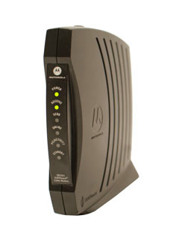
Once you have your computer, you really don't need much additional hardware to connect to the Internet. The primary piece of hardware you need is a modem.
The type of Internet access you choose will determine the type of modem you need. Dial-up access uses a telephone modem, DSL service uses a DSL modem, cable access uses a cable modem, and satellite service uses a satellite adapter. Your ISP may give you a modem—often for a fee—when you sign a contract, which helps ensure that you have the right type of modem. However, if you would prefer to shop for a better or less expensive modem, you can choose to buy one separately.

Router
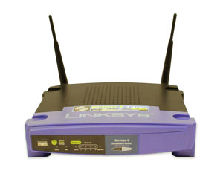
A router is a hardware device that allows you to connect several computers and other devices to a single Internet connection, which is known as a home network. Many routers are wireless, which allows you to create a home wireless network, commonly known as a Wi-Fi network.
You don't necessarily need to buy a router to connect to the Internet. It's possible to connect your computer directly to your modem using an Ethernet cable. Also, many modems include a built-in router, so you have the option of creating a Wi-Fi network without buying extra hardware.

Setting up your Internet connection
Once you've chosen an ISP, most providers will send a technician to your house to turn on the connection. If not, you should be able to use the instructions provided by your ISP—or included with the modem—to set up your Internet connection.
After you have everything set up, you can open your web browser and begin using the Internet. If you have any problems with your Internet connection, you can call your ISP's technical support number.

Home networking
If you have multiple computers at home and want to use all of them to access the Internet, you may want to create a home network, also known as a Wi-Fi network. In a home network, all of your devices connect to your router, which is connected to the modem. This means everyone in your family can use the Internet at the same time.
Your ISP technician may be able to set up a home Wi-Fi network when installing your Internet service. If not, you can review our lesson on How to Set Up a Wi-Fi Network to learn more.
If you want to connect a computer that does not have built-in Wi-Fi connectivity, you can purchase a Wi-Fi adapter that plugs into your computer's USB port.

